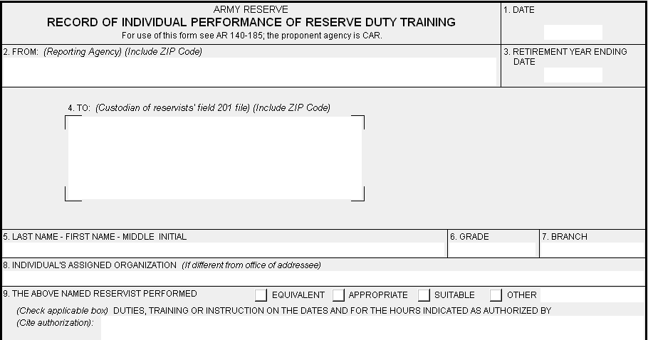
Write Here >>
Your Info
Your Name
Your Unit
O3 Your Branch
20110127
20110127
Your Info
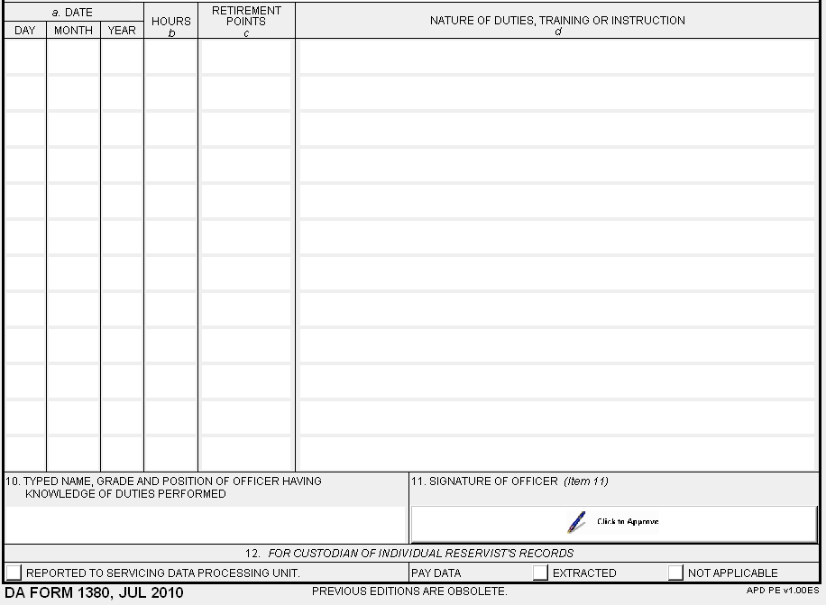
Your Info
Info
Info
1
1
1
1
1
2
2
2
2
2
1000
1000
11
11
???
???
Name

